**Advance Database Management Systems Lab**

**Experiment- 10**

**To understand the concepts of function and procedure in PL/SQL**

**Aryan Mohan**

**500092142**

**Batch- 2**

create database LabExperiment10;

use LabExperiment10;

--1) Write a procedure to accept the value of A, B & C display which is greater.

Create procedure comp_no(@A INTEGER,@B INTEGER,@C INTEGER )

as begin

BEGIN

IF @A>@B AND @A>@C

PRINT 'GREATEST IS A';

ELSE IF @B>@C AND @B>@A

PRINT 'GREATEST IS B';

ELSE

PRINT 'GREATEST IS C';

END;

END

EXECUTE comp_no 100, 200, 50;

Output:



----2) Using procedure create a simple loop that display message “Welcome to PL/SQL Programming” 20 times

create procedure display_message(@message varchar(200) )

as begin

DECLARE @i integer;

set @i=1;

while @i<=20

BEGIN

PRINT @message

set @i=@i+1;

END

END

Execute display_message 'Welcome to PL/SQL Programming';

Output:

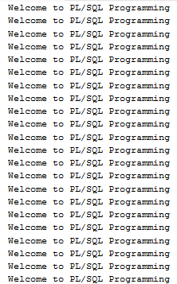

--3) Write procedure to find the factorial of a number.

Create procedure fact(@no int)

as begin

Declare @i int = 1,@fact_no int=1

while (@i<=@no)

Begin

Set @fact_no = @fact_no * @i

Set @i += 1

End

Select @fact_no

End

Execute fact 5;

--4) Write a procedure to generate Fibonacci series.

create procedure Fibonacci(@fibno int)

as begin

declare @f1 INTEGER=0, @f2 INTEGER=1,@f3 INTEGER,@i INTEGER=3,@len INTEGER;

print 'First two number'

print @f1;

print @f2;

print 'fibonacci series is';

while(@i<=@fibno)

begin

set @f3=@f1+@f2;

print @f3

set @f1=@f2;

set @f2=@f3;

set @i=@i+1;

end;

END;

execute Fibonacci 5;

Output:

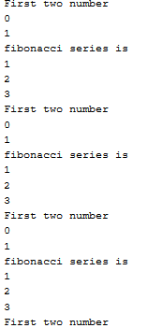

--5) Write a procedure to find the sum of first N numbers

create procedure sum_number(@n integer)

as BEGIN

declare @i integer, @sum integer = 0;

set @i = 1;

while (@i <= @n)

begin

set @sum=@sum+@i

set @i=@i+1

end

print 'sum of first @n numbers'

print @sum

END

EXECUTE sum_number 5;

Output:

